
MARSHALL RANCH ELEMENTARY SCHOOL
SCHOOL SITE ADVISORY CONSTITUTION
AND BY-LAWS
Presented 8-23-22
ARTICLE 1: Marshall Ranch Mission Statement
“Every person matters, every moment counts!”
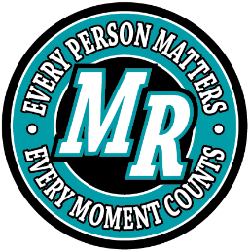

ARTICLE 2: Purpose
Marshall Ranch Site Council Team will support the direction and communication necessary to provide a safe, healthy, and positive learning environment for all students. This vision will be developed in partnership with staff, parents, and community members.
ARTICLE 3: Membership
- Members of the Marshall Ranch Site Council shall minimally include the following:
    - Principal and/or Assistant Principal
    - PTSO President or Vice-President
    - PTSO member-at-large
    - Community member-at-large (If no community member-at-large, membership will consist of two parent-at-large positions)
    - Certified Staff (2)
    - Classified Staff (2)
  - Chairperson of the Site Council shall be the school principal and /or the assistant principal.
  - Responsibilities
    - Promote the involvement of parents and guardians of children enrolled within the district
    - Review student performance in terms of state, district, school goals and make recommendations for improvement
    - Review school policies and curriculum; make recommendations for their improvement
    - Identify and obtain resources that will enhance the education program of the school.
    - Educate us regarding shared decision making
    - Review school budget and make recommendations
    - Monitor and make recommendations to improve school climate
    - Seat committees as needed to address individual issues
ARTICLE 4: Meetings/Calendar
- Meeting times will be determined by consensus of the Site Council at the start of each school year
- All school Site Council meetings will abide by Arizona Revised Statutes of the Open Meeting Law
ARTICLE 5: Amendment
- The by-laws and constitution of Marshall Ranch Site Council may be amended at any time by consensus of the council

MARSHALL RANCH ELEMENTARY
SITE COUNCIL TEAM
MISISON STATEMENT

Marshall Ranch’s Site Council Team will support the direction and communication necessary to provide a safe, healthy, and positive learning environment for all students. This vision will be developed in partnership with staff, parents, and community members.

